### Semester One Examination, 2023

### Question/Answer booklet

# 12 SPECIALIST MATHEMATICS

**UNIT 3**

## Section Two:

## Calculator-assumed

Your Name

Your Teacher’s Name

## Time allowed for this section

Reading time before commencing work: ten minutes

Working time: one hundred minutes

## Materials required/recommended for this section

***To be provided by the supervisor***

This Question/Answer booklet

Formula sheet (retained from Section One)

***To be provided by the candidate***

Standard items: pens (blue/black preferred), pencils (including coloured), sharpener, correction fluid/tape, eraser, ruler, highlighters

Special items: drawing instruments, templates, notes on two unfolded sheets of A4 paper, and up to three calculators approved for use in this examination

## Important note to candidates

No other items may be taken into the examination room. It is **your** responsibility to ensure that you do not have any unauthorised material. If you have any unauthorised material with you, hand it to the supervisor **before** reading any further.

|  |  |  |  |  |  |
| --- | --- | --- | --- | --- | --- |
| **Question** | **Marks** | **Max** | **Question** | **Marks** | **Max** |
| **7** |  |  | **15** |  |  |
| **8** |  |  | **16** |  |  |
| **9** |  |  | **17** |  |  |
| **10** |  |  | **18** |  |  |
| **11** |  |  |
| **12** |  |  |
| **13** |  |  |
| **14** |  |  |

**Structure of this paper**

|  |  |  |  |  |  |
| --- | --- | --- | --- | --- | --- |
| Section | Number of questions available | Number of questions to be answered | Working time (minutes) | Marks available | Percentage of examination |
| Section One:  Calculator-free | 6 | 6 | 50 | 50 | 34 |
| Section Two:  Calculator-assumed | 12 | 12 | 100 | 97 | 66 |
|  |  |  |  | **Total** | 100 |

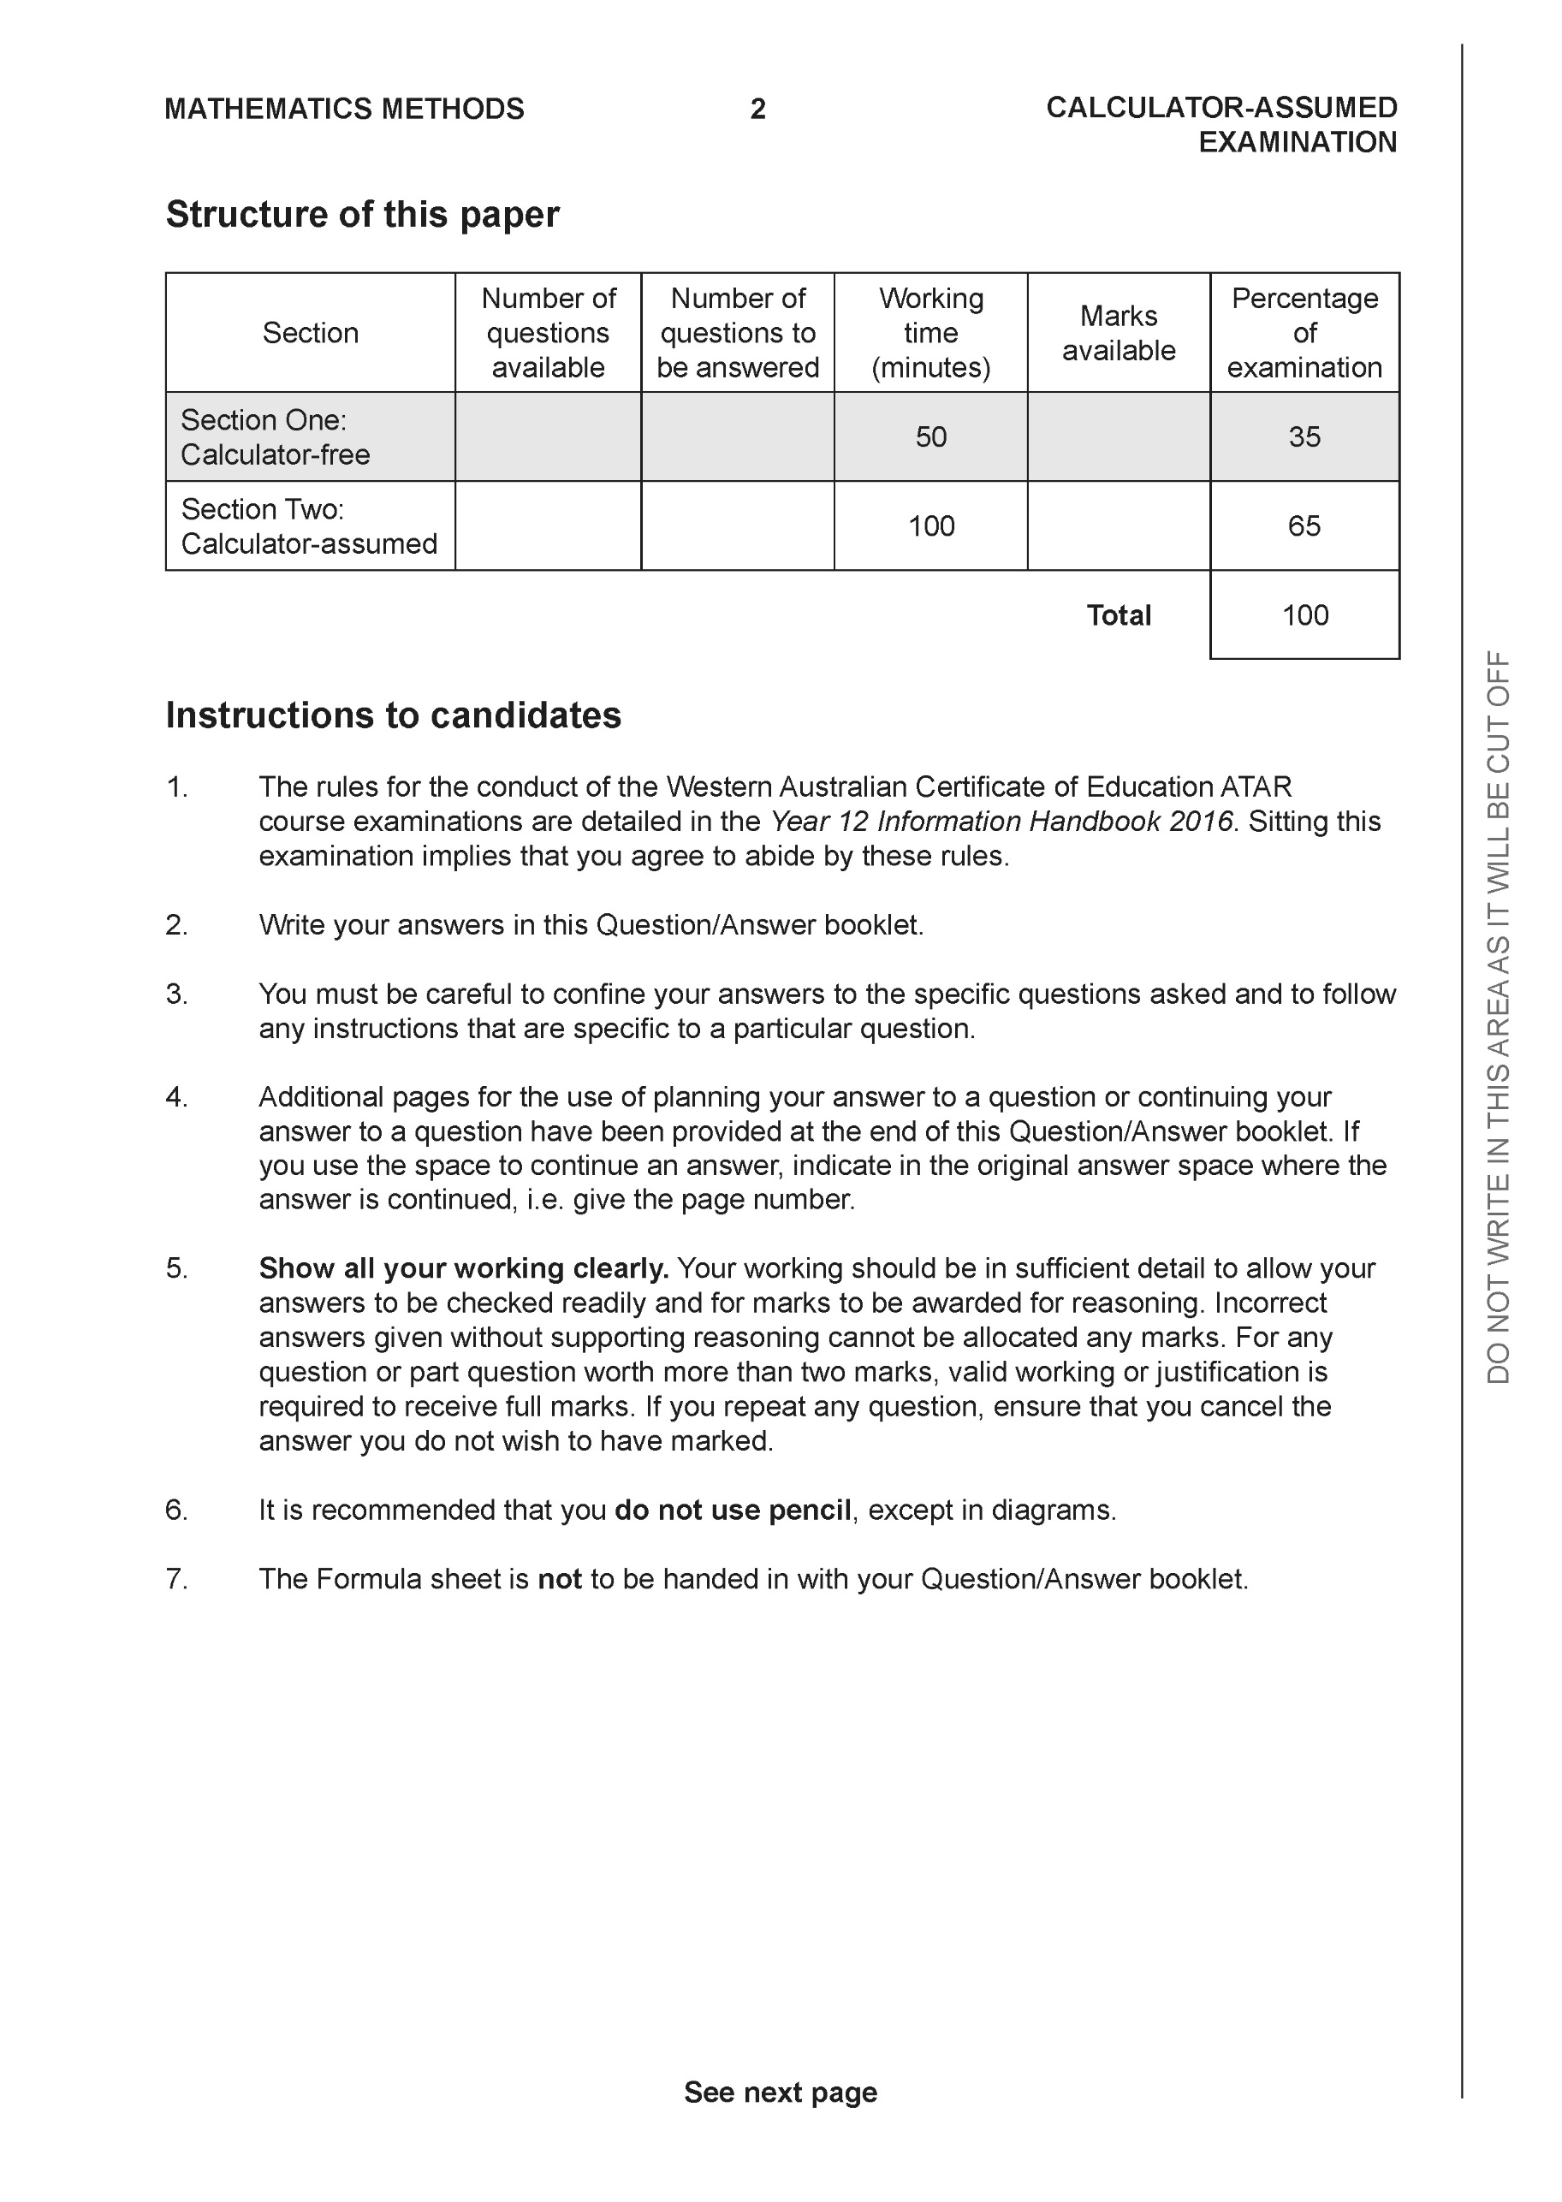

**Section Two: Calculator-assumed (97 Marks)**

This section has **12** questions. Answer **all** questions. Write your answers in the spaces provided.

Spare pages are included at the end of this booklet. They can be used for planning your responses and/or as additional space if required to continue an answer.

● Planning: If you use the spare pages for planning, indicate this clearly at the top of the page.

● Continuing an answer: If you need to use the space to continue an answer, indicate in the original answer space where the answer is continued, i.e. give the page number. Fill in the number of the question that you are continuing to answer at the top of the page.

Working time: 100 minutes.

**Question 7 (5 marks)**

Consider the locus .

1. Sketch the locus on the Argand Diagram below. (2 marks)

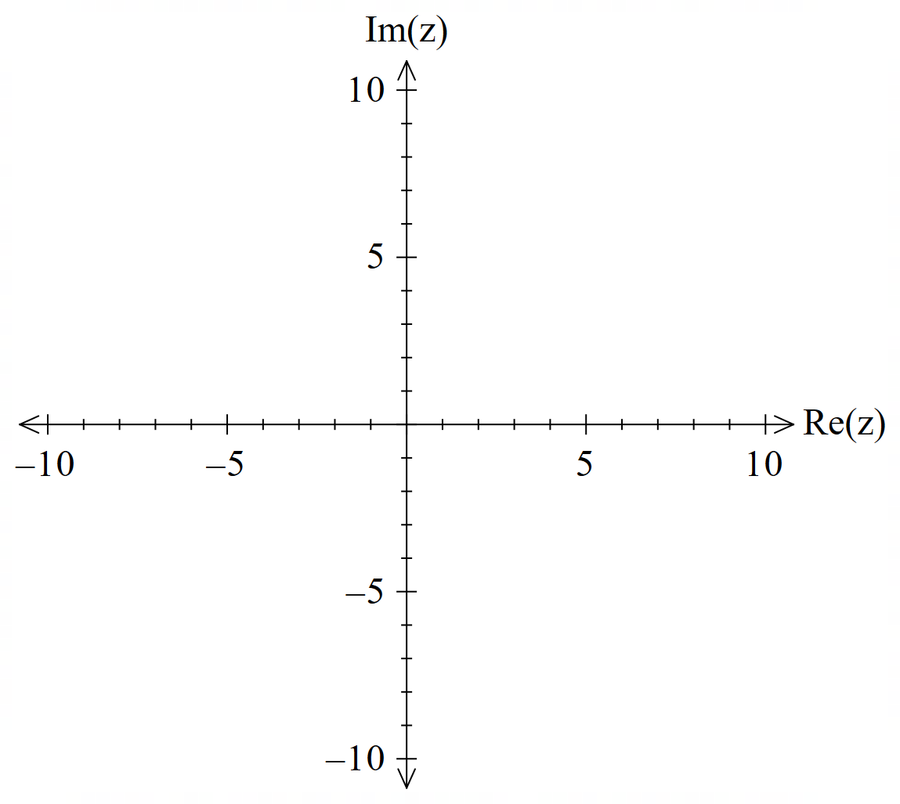

1. Determine the minimum value of: (3 marks)
2. 
3. Arg

**Question 8 (4 marks)**

Consider the plane  and the point A.

Determine the distance of point A from the plane.

**Question 9 (9 marks)**

Consider the rectangular box with vertices A(5,0,0), B(5,4,0),C(0,4,0), D(0,4,7), E(5,4,7),F(5,0,7)&G(0,0,7) and the origin.

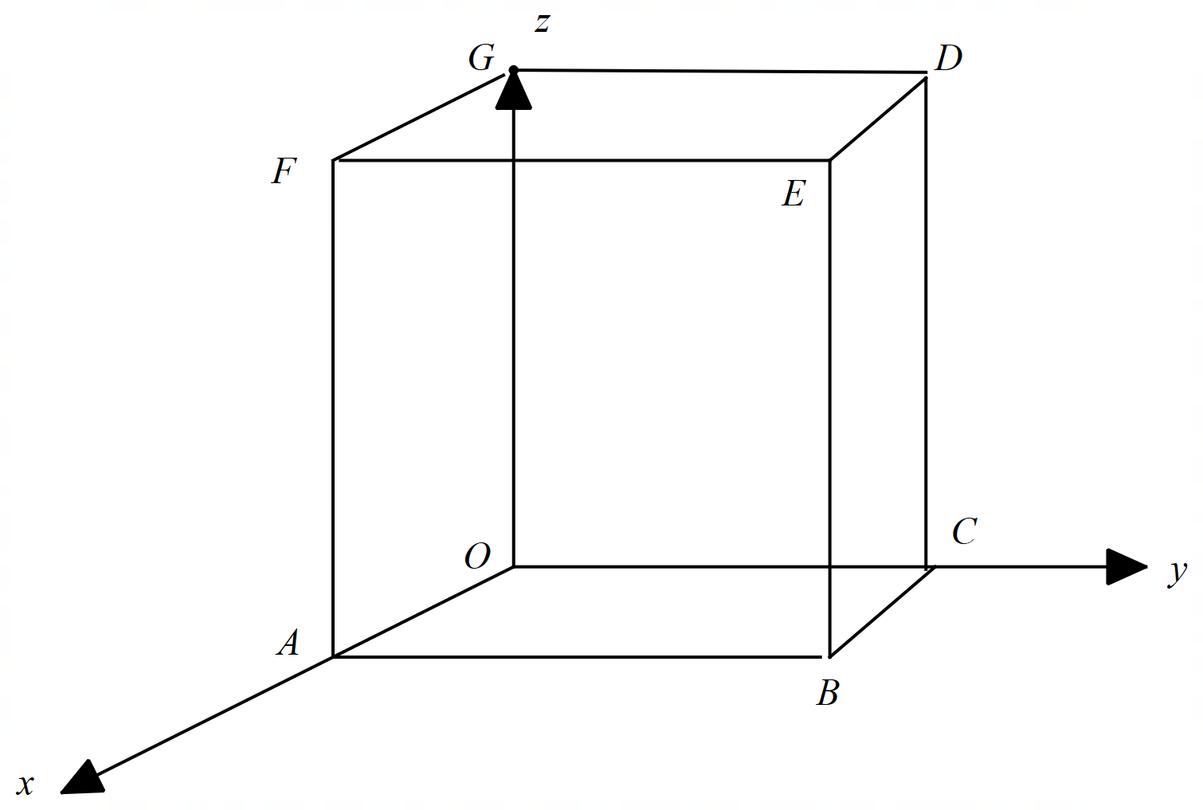

**Continued next page**

**Q9 continued-**

1. If point H divides the diagonal  in the ratio 3:2, determine the position vector .

(2 marks)

1. Determine the cartesian equation of the plane that contains the points A, G & B.

(4 marks)

1. Prove that the diagonals of the box above, bisect each other using vectors.

(3 marks)

**Question 10 (6 marks)**

Consider the complex numbers .

 , Arg

 , 



1. Determine the exact value of  (3 marks)
2. Determine the exact value of Arg. (3 marks)

**Question 11 (6 marks)**

Consider the sphere  , where  is a positive constant, and the line .

Determine all possible values of such that:

1. There is only one point of contact between sphere and line.
2. There are two points of contact between sphere and line.
3. There are no points of contact between sphere and line.

**Q11 continued.**

**Question 12 (6 marks)**

Particles and are moving with constant velocities and have initial positions m and m respectively. seconds later is at m.

(a) Determine the velocity of . (1 mark)

Q12 cont-

The velocity of is m/s.

(b) Show that the paths of and cross, state the position vector of this point, and explain whether the particles collide. (5 marks)

**Question 13 (8 marks)**

(a) Determine the equations of all asymptotes of the graph of when

(i) . (2 marks)

(ii) . (2 marks)

<EFOFEX>
id:fxd{e1b665de-a898-4a08-b32c-b659d84af5de}

FXData:

</EFOFEX>

(b) The graph of is shown  
in the diagram, together with its  
three asymptotes.  
  
The defining rule is given by  
  
 and are positive  
integer constants.  
  
Determine, with brief reasons, the value of and . (4 marks)

**Question 14 (9 marks)**

<EFOFEX>
id:fxd{b78cbe72-dad2-4e1f-a439-a6fe7385015e}

FXData:
</EFOFEX>(a) Draw the subset of the complex plane determined by on the axes below.

(3 marks)

<EFOFEX>
id:fxd{cccd6404-f270-44de-a75e-9037446c66f1}

FXData:

</EFOFEX>

(b) The circular arc in the diagram represents  
the locus of a complex number .  
  
  
Without using or , write  
equations or inequalities in terms of   
for the indicated locus.  
  
  
  
 (3 marks)

(c) Describe the subset, or sketch, of the complex plane determined by

.

(3 marks)

**Question 15 (8 marks)**

(a) Determine all solutions to the equation in exact polar form. (3 marks)

(b) Consider the seventh roots of unity expressed in polar form .

(i) Determine the roots for which . (2 marks)

(ii) Use all seven roots to show that . (3 marks)

**Question 16 (15 marks)**

The complex number has been plotted on the Argand diagram below.

<EFOFEX>

id:fxd{f46fdef6-7461-4ebb-8f7c-86afe977dc1e}


FXData:


</EFOFEX>

(a) Express in Cartesian form. (1 mark)

(b) Express in polar form. (3 marks)

(c) The complex number is a root of , with the smallest positive argument.

(i) Given that , determine in polar form. (3 marks)

(ii) Determine the remaining roots in polar form. Label the roots as and  
 moving in an anticlockwise direction from the positive real axis. (2 marks)

**Q16 cont-**

(d) Determine the exact polar form of . (3 marks)

, and are roots of .

(d) Determine the values of and . (3 marks)

**Question 17 (12 marks)**

Two parallel mirrors are shown in the diagram below. The larger mirror passes through the origin and is coincident with the plane, and the smaller mirror is in the plane .

<EFOFEX>

id:fxd{8e8486ce-c10d-4609-89a7-20df4454bf4c}


FXData:


</EFOFEX>

A laser beam is fired through a small hole at the origin. The dotted line shows one such beam. The beam then hits the mirror at and is reflected back towards the larger mirror.

The laser beam is pointed with direction .

(a) Determine the position vector of, , the point where the beam hits the smaller mirror.  
 (4 marks)

The laser beam is then reflected with direction .

(b) Determine the position vector of, , the point where the beam hits the larger mirror.  
 (3 marks)

A second beam is fired from the origin with a direction of . When it hits the smaller mirror, it is then reflected with direction of . You may assume that the speed of the beam does not change.

There are laser beams from the origin which after being reflected in the small mirror do not hit the larger mirror.

(c) Determine the range of values of and , that ensure the beams **are reflected** in  
the larger mirror. (5 marks)

**Question 18 (9 marks)**

The graph of is shown with a dotted curve on the axes below.

<EFOFEX>

id:fxd{94a2eda1-8b9d-4b74-b6e8-5dc46eff3207}


FXData:


</EFOFEX>

(a) On the same axes draw the graph of . (4 marks)

(b) (i) The equation has solutions for what range of values of ? (2 marks)

(ii) Does the equation ever have exactly solutions? (1 marks)

(c) Determine the solutions to . (2 marks)

Q18 continued

Additional working space

Question number:

Additional working space

Question number:

Additional working space

Question number: